**HOW OUR PROJECT IS?**

**We have created Login First if you give the wrong username or password it will show an error then the main page opens and you have a multi-choice sedan rent sports that also sells used and new cars then you have to select 1 option which you have came for then it will display some pictures of the car click buy now then it will ask you about payment info after that your info will be saved in our page top deliver the car**

Our project is all about a showroom (Wolf car showroom)which we owned in this showroom we sell new as well as pre-used cars and also we have a good collection of luxury cars some of them are also pre-used but their condition is good as new. We also provide cars on rent for tourists. We also have some antique queens for drift and car lovers. We always want to provide good service to our customers for that we also have an online buying system all you have to do is go to our website and log in with the correct username and password to avoid errors. After when you are in see options like which do you want to buy luxury, sedan, old or new you just have to click on details and the next interface opens which is all about the details of the car and if that car suits you and you want to buy it. You just have to click on buy and put your details and submit .thats it

And also try to deliver your car to your address which you have given as soon as possible.

Thank you.

1. LOGIN PAGE
2. LOGIN ERROR
3. MAIN SHOWROOM PAGE
4. CARS PICTURES
5. BUY BUTTON
6. BANK INFORMATION
7. SAVES DATA TO CONFRIM

**The Login page code :**

package ShowroomApplication;

import javafx.application.Application;

import javafx.event.ActionEvent;

import javafx.event.EventHandler;

import javafx.stage.Stage;

import javafx.scene.Group;

import javafx.scene.Scene;

import javafx.scene.control.Button;

import javafx.scene.control.CheckBox;

import javafx.scene.control.Label;

import javafx.scene.control.PasswordField;

import javafx.scene.control.TextField;

import javafx.scene.image.Image;

import javafx.scene.image.ImageView;

import javafx.scene.paint.Color;

import javafx.scene.text.Font;

import javafx.scene.text.Text;

public class Loginpage extends Application implements EventHandler<ActionEvent> {

public static void main(String[] args) {

launch(args);

}

@Override

public void start(Stage primaryStage) throws Exception {

Stage stage = new Stage();

stage.setResizable(false);

Group root = new Group();

Scene scene = new Scene(root, 400, 400, Color.CORNSILK);

stage.setTitle("Login");

Text pagetitle = new Text("Please Login First");

pagetitle.setLayoutY(60);

pagetitle.setLayoutX(70);

pagetitle.setFont(Font.font(40));

pagetitle.setFill(Color.WHITE);

TextField userfield = new TextField();

userfield.setLayoutY(100);

userfield.setLayoutX(130);

userfield.setPromptText("UserName");

userfield.setFocusTraversable(true);

PasswordField passfield = new PasswordField();

passfield.setLayoutY(140);

passfield.setLayoutX(130);

passfield.setPromptText("Password");

passfield.setFocusTraversable(true);

Button b1 = new Button("Login");

b1.setLayoutY(200);

b1.setLayoutX(180);

b1.setOnAction(this);

CheckBox c1 = new CheckBox("I Am Not Robot");

c1.setLayoutX(145);

c1.setLayoutY(250);

c1.setTextFill(Color.WHITE);

Image bi = new Image(

"file:///Users/qadirdad_kazi/Desktop/Programming/Java/Eclips/Application/oopproject1/src/loginPageImage/loginback.jpg");

ImageView backg = new ImageView(bi);

root.getChildren().add(backg);

root.getChildren().add(c1);

root.getChildren().add(b1);

root.getChildren().add(passfield);

root.getChildren().add(userfield);

root.getChildren().add(pagetitle);

stage.setScene(scene);

stage.show();

// error message

final Label flabel = new Label();

flabel.setLayoutY(300);

flabel.setLayoutX(110);

flabel.setTextFill(Color.RED);

flabel.setFont(Font.font(20));

root.getChildren().add(flabel);

// Giving action to login button for new screen

b1.setOnAction(new EventHandler<ActionEvent>() {

@Override

public void handle(ActionEvent event) {

if (userfield.getText().equals("qadirdad") && (passfield.getText().equals("kazi")) & c1.isSelected()) {

flabel.setText("LOGIN Sucessfull");

display1 newscreen = new display1();

try {

newscreen.start(stage);

} catch (Exception e) {

}

}

else if (userfield.getText().equals("khayam")

&& (passfield.getText().equals("57327")) & c1.isSelected()) {

flabel.setText("LOGIN Sucessfull");

display1 newscreen = new display1();

try {

newscreen.start(stage);

} catch (Exception e) {

}

} else if (userfield.getText().equals("osama")

&& (passfield.getText().equals("rehman")) & c1.isSelected()) {

flabel.setText("LOGIN Sucessfull");

display1 newscreen = new display1();

try {

newscreen.start(stage);

} catch (Exception e) {

}

} else if (userfield.getText().equals("rizwan")

&& (passfield.getText().equals("ali")) & c1.isSelected()) {

flabel.setText("LOGIN Sucessfull");

display1 newscreen = new display1();

try {

newscreen.start(stage);

} catch (Exception e) {

}

} else {

Loginerror newscreen = new Loginerror();

try {

newscreen.start(stage);

} catch (Exception e) {

} } } });}

@Override

public void handle(ActionEvent event) {

// TODO Auto-generated method stub

}}

**Login page error message :**

*@Override*

public void start(Stage primaryStage) throws Exception {

Stage stage = new Stage();

stage.setResizable(false);

Group root = new Group();

Scene scene = new Scene(root,300,200,Color.***BISQUE***);

Text errortext = new Text("Userame or Password Is Wrong \n \n Check If You Are Not a Robot");

errortext.setY(30);

errortext.setFill(Color.***DARKRED***);

errortext.setFont(Font.*font*(20));

Text ortext = new Text("OR");

ortext.setY(55);

ortext.setX(120);

ortext.setFont(Font.*font*(20));

Button cancelbutton = new Button("Cancel");

cancelbutton.setLayoutY(100);

cancelbutton.setLayoutX(120);

cancelbutton.setOnAction(e->{

stage.close();

});

root.getChildren().addAll(errortext , ortext , cancelbutton);

stage.setScene(scene);

stage.show();

}

}

**After login Main screen select which car we need:**

package ShowroomApplication;

import javafx.application.Application;

import javafx.collections.ObservableList;

import javafx.scene.Group;

import javafx.scene.Scene;

import javafx.scene.control.ComboBox;

import javafx.scene.effect.Reflection;

import javafx.scene.image.Image;

import javafx.scene.image.ImageView;

import javafx.scene.layout.HBox;

import javafx.scene.paint.Color;

import javafx.scene.text.Font;

import javafx.scene.text.Text;

import javafx.stage.Stage;

public class display1 extends Application {

public static void main(String[] args) {

launch(args);

}

@Override

public void start(Stage primaryStage) throws Exception {

ComboBox <String> choice1 = new ComboBox<>();

choice1.getItems().addAll("Old Model","New Model");

choice1.setPrefSize(115, 40);

choice1.setLayoutX(215);

choice1.setLayoutY(0);

choice1.setValue("Sedan Cars");

//Choice box for rent

ComboBox <String> choice2 = new ComboBox<>();

ObservableList<String> list2 = choice2.getItems();

list2.addAll("Rent a Car");

choice2.setPrefSize(115, 40);

choice2.setLayoutX(420);

choice2.setLayoutY(0);

choice2.setValue("Rent");

//Choice Box for Sports car

ComboBox <String> choice3 = new ComboBox<>();

ObservableList<String> list3 = choice3.getItems();

list3.addAll("Old Model","New Model");

choice3.setPrefSize(115, 40);

choice3.setLayoutX(630);

choice3.setLayoutY(0);

choice3.setValue("Sport Cars");

//Display Text

Text ht = new Text();

ht.setText("Wolf Automobils Showroom");

ht.setFont(Font.font(40));

ht.setLineSpacing(1);

ht.setY(100);

ht.setX(250);

ht.setFill(Color.WHITE);

ht.setUnderline(true);

//Setting Reflection

Reflection reflection = new Reflection();

reflection.setFraction(0.8);

//Setting the effect to the text

ht.setEffect(reflection);

//Hbox for choice Box

HBox h1 = new HBox(10 ,ht);

Image image = new Image("file:///Users/qadirdad_kazi/Desktop/Programming/Java/

ImageView img = new ImageView(image);

img.setFitHeight(500);

img.setFitWidth(900);

Stage stage = new Stage ();

stage.setTitle("Welcome to main page");

stage.setResizable(false);

Group v = new Group(img,choice1,choice2,choice3);

v.getChildren().addAll(h1,ht);

Scene scene = new Scene(v , 900, 500 , Color.DARKGRAY);

stage.setScene(scene);

stage.show();

//Event handling choice box

choice1.setOnAction(e->{

String selectedvalue1 = choice1.getValue();

if(selectedvalue1.equals("New Model")) {

newSedan newscreen2 = new newSedan();

try {

newscreen2.start(stage);

} catch (Exception e1) {

// TODO Auto-generated catch block

e1.printStackTrace();

}}

else if(selectedvalue1.equals("Old Model")){

oldSedan newscreen2 = new oldSedan();

try {

newscreen2.start(stage);

} catch (Exception e1) {

// TODO Auto-generated catch block

e1.printStackTrace();

}});

choice2.setOnAction(e->{

String selectedvalue2 = choice2.getValue();

if(selectedvalue2.equals("Rent a Car")) {

rentcar newscreen2 = new rentcar();

try {

newscreen2.start(stage);

} catch (Exception e1) {

// TODO Auto-generated catch block

e1.printStackTrace();

}}});

choice3.setOnAction(e->{

String selectedvalue3 = choice3.getValue();

if(selectedvalue3.equals("New Model")) {

sportsnew newscreen3 = new sportsnew();

try {

newscreen3.start(stage);

} catch (Exception e1) {

// TODO Auto-generated catch block

e1.printStackTrace();

}}

else if(selectedvalue3.equals("Old Model")) {

sportsold newscreen3 = new sportsold();

try {

newscreen3.start(stage);

} catch (Exception e1) {

// TODO Auto-generated catch block

e1.printStackTrace();

}}});}}

**New sedan car:**

public static void main(String[] args) {

*launch*(args);

}

*@Override*

public void start(Stage primaryStage) throws Exception {

Stage stage = new Stage();

stage.setResizable(false);

Group root = new Group();

Scene scene = new Scene (root , 1920 , 1080 , Color.***BISQUE***);

Text t1 = new Text("Welcome to Latest Sedan page");

t1.setFont(Font.*font*(50));

t1.setFill(Color.***ALICEBLUE***);

t1.setUnderline(true);

t1.setLayoutY(160);

t1.setLayoutX(300);

//car1

Image image1 = new Image("file:///Users/qadirdad_kazi/Desktop/Programming/Java/EclipsedanNew1.jpeg");

ImageView img1 = new ImageView(image1);

img1.setLayoutX(100);

img1.setLayoutY(300);

Button b1 = new Button("Details");

b1.setLayoutX(230);

b1.setLayoutY(470);

b1.setTextFill(Color.***BLACK***);

//car2

Image image2 = new Image("file:///Users/qadirdad_kazi/Desktop/Programming/Javaoopproject1/src/newSedancar/SedanNew2.jpeg");

ImageView img2 = new ImageView(image2);

img2.setLayoutX(420);

img2.setLayoutY(300);

Button b2 = new Button("Details");

b2.setLayoutX(550);

b2.setLayoutY(470);

b2.setTextFill(Color.***BLACK***);

//car3

Image image3 = new Image("file:///Users/qadirdad_kazi/Desktop/Programming/Java/Eclips/Applica/src/newSedancar/SedanNew4.jpeg");

ImageView img3 = new ImageView(image3);

img3.setLayoutX(100);

img3.setLayoutY(530);

Button b3 = new Button("Details");

b3.setLayoutX(230);

b3.setLayoutY(700);

b3.setTextFill(Color.***BLACK***);

//car4

Image image4 = new Image("file:///Users/qadirdad_kazi/Desktop/Programming/Java/Eclips/Application/oopprojedanNew5.jpeg");

ImageView img4 = new ImageView(image4);

img4.setLayoutX(420);

img4.setLayoutY(530);

Button b4 = new Button("Details");

b4.setLayoutX(550);

b4.setLayoutY(700);

b4.setTextFill(Color.***BLACK***);

//car5

Image image5 = new Image("file:///Users/qadirdad_kazi/Desktop/Programming/Java/Eclips/Application/oopproject1/srcedannew6.jpg");

ImageView img5 = new ImageView(image5);

img5.setLayoutX(750);

img5.setLayoutY(300);

Button b5 = new Button("Details");

b5.setLayoutX(875);

b5.setLayoutY(470);

b5.setTextFill(Color.***BLACK***);

//car6

Image image6 = new Image("file:///Users/qadirdaProgramming/Java/Eclips/Application/oopproject1/src/newSedancar/newsedan7.jpg");

ImageView img6 = new ImageView(image6);

img6.setLayoutX(750);

img6.setLayoutY(530);

Button b6 = new Button("Details");

b6.setLayoutX(875);

b6.setLayoutY(700);

b6.setTextFill(Color.***BLACK***);

//Titlebackground image

Image bi = new Image("file:///UseApplication/oopproject1/src/oldSedancar/osman-rana-9rRBct37OAI-unsplash.jpg");

ImageView backg = new ImageView(bi);

backg.setFitWidth(1080);

backg.setFitHeight(900);

Image bi2 = new Image("file:///Users/qadirdad_kazi/Desktop/Programming/Java/Eclips/Application/oopproject1/src/newSedancar/jake-pierrelee-CJHtw3W56b8-unsplash.jpg");

ImageView titleimg2 = new ImageView(bi2);

titleimg2.setFitHeight(900);

titleimg2.setFitWidth(500);

titleimg2.setLayoutX(1000);

b1.setOnAction(e->{

NewSedancar1 newscreen=new NewSedancar1();

try {

newscreen.start(stage);

} catch (Exception e1) {

}});

b2.setOnAction(e->{

NewSedancar2 newscreen=new NewSedancar2();

try {

newscreen.start(stage);

} catch (Exception e1) {

}});

b3.setOnAction(e->{

NewSedancar3 newscreen=new NewSedancar3();

try {

newscreen.start(stage);

} catch (Exception e1) {

}});

b4.setOnAction(e->{

NewSedancar4 newscreen=new NewSedancar4();

try {

newscreen.start(stage);

} catch (Exception e1) {

}});

b5.setOnAction(e->{

NewSedancar5 newscreen=new NewSedancar5();

try {

newscreen.start(stage);

} catch (Exception e1) {

}});

b6.setOnAction(e->{

NewSedancar6 newscreen=new NewSedancar6();

try {

newscreen.start(stage);

} catch (Exception e1) {

}});

stage.setTitle("New Sedan Cars");

root.getChildren().add( backg);

root.getChildren().add(titleimg2);

root.getChildren().add(img1);

root.getChildren().add(img2);

root.getChildren().add(img3);

root.getChildren().add(img4);

root.getChildren().add(img5);

root.getChildren().add(img6);

root.getChildren().add(t1);

root.getChildren().add(b1);

root.getChildren().add(b2);

root.getChildren().add(b3);

root.getChildren().add(b4);

root.getChildren().add(b5);

root.getChildren().add(b6);

stage.setScene(scene);

stage.show();

}

}

**Old sedan car :**

*@Override*

public void start(Stage primaryStage) throws Exception {

Stage stage = new Stage();

stage.setResizable(false);

Group root = new Group();

Scene scene = new Scene (root , 1920 , 1080 , Color.***BISQUE***);

Text t1 = new Text("Welcome to Classic Sedan page");

t1.setFont(Font.*font*(50));

t1.setFill(Color.***ALICEBLUE***);

t1.setUnderline(true);

t1.setLayoutY(200);

t1.setLayoutX(300);

//car1

Image image1 = new Image("file:///Users/qadirdad_kazi/Desktop/Programming/Java/Eclips/Application/oopproject1/src/oldSedancar/SedanOld1.jpeg");

ImageView img1 = new ImageView(image1);

img1.setLayoutX(100);

img1.setLayoutY(300);

Button b1 = new Button("Details");

b1.setLayoutX(230);

b1.setLayoutY(470);

b1.setTextFill(Color.***BLACK***);

//car2

Image image2 = new Image("file:///Users/qadirdad_kazi/Desktop/Programming/Java/Eclips/Application/oopproject1/src/oldSedancar/SedanOld2.jpeg");

ImageView img2 = new ImageView(image2);

img2.setLayoutX(420);

img2.setLayoutY(300);

Button b2 = new Button("Details");

b2.setLayoutX(550);

b2.setLayoutY(470);

b2.setTextFill(Color.***BLACK***);

//car3

Image image3 = new Image("file:///Users/qadirdad_kazi/Desktop/Programming/Java/Eclips/Application/oopproject1/src/oldSedancar/SedanOld3.jpeg");

ImageView img3 = new ImageView(image3);

img3.setLayoutX(100);

img3.setLayoutY(530);

Button b3 = new Button("Details");

b3.setLayoutX(230);

b3.setLayoutY(700);

b3.setTextFill(Color.***BLACK***);

//car4

Image image4 = new Image("file:///Users/qadirdad_kazi/Desktop/Programming/Java/Eclips/Application/oopproject1/src/oldSedancar/SedanOld4.jpeg");

ImageView img4 = new ImageView(image4);

img4.setLayoutX(420);

img4.setLayoutY(530);

Button b4 = new Button("Details");

b4.setLayoutX(550);

b4.setLayoutY(700);

b4.setTextFill(Color.***BLACK***);

//car5

Image image5 = new Image("file:///Users/qadirdad_kazi/Desktop/Programming/Java/Eclips/Application/oopproject1/src/oldSedancar/SedanOld5.jpeg");

ImageView img5 = new ImageView(image5);

img5.setLayoutX(750);

img5.setLayoutY(300);

Button b5 = new Button("Details");

b5.setLayoutX(875);

b5.setLayoutY(470);

b5.setTextFill(Color.***BLACK***);

//car6

Image image6 = new Image("file:///Users/qadirdad_kazi/Desktop/Programming/Java/Eclips/Application/oopproject1/src/oldSedancar/SedanOld6.jpeg");

ImageView img6 = new ImageView(image6);

img6.setLayoutX(750);

img6.setLayoutY(530);

Button b6 = new Button("Details");

b6.setLayoutX(875);

b6.setLayoutY(700);

b6.setTextFill(Color.***BLACK***);

//Titlebackground image

Image bi = new Image("file:///Users/qadirdad_kazi/Desktop/Programming/Java/Eclips/Application/oopproject1/src/oldSedancar/osman-rana-9rRBct37OAI-unsplash.jpg");

ImageView backg = new ImageView(bi);

backg.setFitWidth(1080);

backg.setFitHeight(900);

Image bi2 = new Image("file:///Users/qadirdad_kazi/Desktop/Programming/Java/Eclips/Application/oopproject1/src/oldSedancar/sideSedan.jpg");

ImageView titleimg2 = new ImageView(bi2);

titleimg2.setFitHeight(900);

titleimg2.setFitWidth(500);

titleimg2.setLayoutX(1050);

b1.setOnAction(e->{

OldSedancar1 newscreen=new OldSedancar1();

try {

newscreen.start(stage);

} catch (Exception e1) {

}});

b2.setOnAction(e->{

OldSedancar2 newscreen=new OldSedancar2();

try {

newscreen.start(stage);

} catch (Exception e2) {

}});

b3.setOnAction(e->{

OldSedancar3 newscreen=new OldSedancar3();

try {

newscreen.start(stage);

} catch (Exception e3) {

} });

b4.setOnAction(e->{

OldSedancar4 newscreen=new OldSedancar4();

try {

newscreen.start(stage);

} catch (Exception e4) {

}});

b5.setOnAction(e->{

OldSedancar5 newscreen=new OldSedancar5();

try {

newscreen.start(stage);

} catch (Exception e5) {

}});

b6.setOnAction(e->{

OldSedancar6 newscreen=new OldSedancar6();

try {

newscreen.start(stage);

} catch (Exception e6) {

}});

stage.setTitle("Old Sedan Cars");

root.getChildren().add( backg);

root.getChildren().add(titleimg2);

root.getChildren().add(img1);

root.getChildren().add(img2);

root.getChildren().add(img3);

root.getChildren().add(img4);

root.getChildren().add(img5);

root.getChildren().add(img6);

root.getChildren().add(t1);

root.getChildren().add(b1);

root.getChildren().add(b2);

root.getChildren().add(b3);

root.getChildren().add(b4);

root.getChildren().add(b5);

root.getChildren().add(b6);

stage.setScene(scene);

stage.show();

}}

**Rent a car:**

public class rentcar extends Application {

public static void main(String[] args) {

*launch*(args);

}

*@Override*

public void start(Stage primaryStage) throws Exception {

Stage stage = new Stage();

stage.setResizable(false);

Group root = new Group();

Scene scene = new Scene (root , 1140 , 1080 , Color.***BISQUE***);

Text t1 = new Text("RENT A CAR");

t1.setFont(Font.*font*(50));

t1.setFill(Color.***YELLOW***);

t1.setUnderline(true);

t1.setLayoutY(180);

t1.setLayoutX(425);

//car1

Image image1 = new Image("file:///Users/qadirdad_kazi/Desktop/Programming/Java/Eclips/Application/oopproject1/src/rentCarImages/car1.jpg");

ImageView img1 = new ImageView(image1);

img1.setLayoutX(100);

img1.setLayoutY(300);

Button b1 = new Button("Details");

b1.setLayoutX(230);

b1.setLayoutY(450);

b1.setTextFill(Color.***BLACK***);

//car2

Image image2 = new Image("file:///Users/qadirdad_kazi/Desktop/Programming/Java/Eclips/Application/oopproject1/src/rentCarImages/car%202.jpg");

ImageView img2 = new ImageView(image2);

img2.setLayoutX(420);

img2.setLayoutY(300);

Button b2 = new Button("Details");

b2.setLayoutX(550);

b2.setLayoutY(460);

b2.setTextFill(Color.***BLACK***);

//car3

Image image3 = new Image("file:///Users/qadirdad_kazi/Desktop/Programming/Java/Eclips/Application/oopproject1/src/rentCarImages/car%203.jpg");

ImageView img3 = new ImageView(image3);

img3.setLayoutX(100);

img3.setLayoutY(530);

Button b3 = new Button("Details");

b3.setLayoutX(230);

b3.setLayoutY(660);

b3.setTextFill(Color.***BLACK***);

//car4

Image image4 = new Image("file:///Users/qadirdad_kazi/Desktop/Programming/Java/Eclips/Application/oopproject1/src/rentCarImages/car%205.jpg");

ImageView img4 = new ImageView(image4);

img4.setLayoutX(420);

img4.setLayoutY(530);

Button b4 = new Button("Details");

b4.setLayoutX(550);

b4.setLayoutY(720);

b4.setTextFill(Color.***BLACK***);

//car5

Image image5 = new Image("file:///Users/qadirdad_kazi/Desktop/Programming/Java/Eclips/Application/oopproject1/src/rentCarImages/car%204.jpg");

ImageView img5 = new ImageView(image5);

img5.setLayoutX(750);

img5.setLayoutY(300);

Button b5 = new Button("Details");

b5.setLayoutX(875);

b5.setLayoutY(440);

b5.setTextFill(Color.***BLACK***);

//car6

Image image6 = new Image("file:///Users/qadirdad_kazi/Desktop/Programming/Java/Eclips/Application/oopproject1/src/rentCarImages/car%206.jpg");

ImageView img6 = new ImageView(image6);

img6.setLayoutX(750);

img6.setLayoutY(530);

Button b6 = new Button("Details");

b6.setLayoutX(875);

b6.setLayoutY(680);

b6.setTextFill(Color.***BLACK***);

//Titlebackground image

Image bi = new Image("file:///Users/qadirdad_kazi/Desktop/Programming/Java/Eclips/Application/oopproject1/src/rentCarImages/BACKGROUND%20IMAGE.png");

ImageView backg = new ImageView(bi);

backg.setFitWidth(1920);

//ackg.setX(500);

//backg.setY(100);

backg.setFitHeight(850);

backg.setFitWidth(1300);

b1.setOnAction(e->{

RentAcar1 newscreen=new RentAcar1();

try {

newscreen.start(stage);

} catch (Exception e1) {

}});

b2.setOnAction(e->{

RentAcar2 newscreen=new RentAcar2();

try {

newscreen.start(stage);

} catch (Exception e2) {

}});

b3.setOnAction(e->{

RentAcar3 newscreen=new RentAcar3();

try {

newscreen.start(stage);

} catch (Exception e3) {

} });

b4.setOnAction(e->{

RentAcar4 newscreen=new RentAcar4();

try {

newscreen.start(stage);

} catch (Exception e4) {

}});

b5.setOnAction(e->{

RentAcar5 newscreen=new RentAcar5();

try {

newscreen.start(stage);

} catch (Exception e5) {

}});

b6.setOnAction(e->{

RentAcar6 newscreen=new RentAcar6();

try {

newscreen.start(stage);

} catch (Exception e6) {

}});

stage.setTitle("Rent a car page");

//root.setBackground(bGround);

root.getChildren().add(backg);

root.getChildren().add(img1);

root.getChildren().add(img2);

root.getChildren().add(img3);

root.getChildren().add(img4);

root.getChildren().add(img5);

root.getChildren().add(img6);

root.getChildren().add(t1);

root.getChildren().add(b1);

root.getChildren().add(b2);

root.getChildren().add(b3);

root.getChildren().add(b4);

root.getChildren().add(b5);

root.getChildren().add(b6);

stage.setScene(scene);

stage.show();

}}

**New sports car:**

public class sportsnew extends Application {

public static void main(String[] args) {

*launch*(args);

}

*@Override*

public void start(Stage primaryStage) throws Exception {

Stage stage = new Stage();

stage.setResizable(false);

Group root = new Group();

Scene scene = new Scene (root , 1920 , 1080 , Color.***BISQUE***);

Text t1 = new Text("Welcome to Sports cars page");

t1.setFont(Font.*font*(50));

t1.setFill(Color.***ALICEBLUE***);

t1.setUnderline(true);

t1.setLayoutY(180);

t1.setLayoutX(320);

//car1

Image image1 = new Image("file:///Users/qadirdad_kazi/Desktop/Programming/Java/Eclips/Application/oopproject1/src/sportsNewImages/SportsImg1new.jpg");

ImageView img1 = new ImageView(image1);

img1.setLayoutX(100);

img1.setLayoutY(300);

Button b1 = new Button("Details");

b1.setLayoutX(230);

b1.setLayoutY(470);

b1.setTextFill(Color.***BLACK***);

//car2

Image image2 = new Image("file:///Users/qadirdad_kazi/Desktop/Programming/Java/Eclips/Application/oopproject1/src/sportsNewImages/sportsimg2new.jpg");

ImageView img2 = new ImageView(image2);

img2.setLayoutX(420);

img2.setLayoutY(300);

Button b2 = new Button("Details");

b2.setLayoutX(550);

b2.setLayoutY(470);

b2.setTextFill(Color.***BLACK***);

//car3

Image image3 = new Image("file:///Users/qadirdad_kazi/Desktop/Programming/Java/Eclips/Application/oopproject1/src/sportsNewImages/sportsimg3new.jpg");

ImageView img3 = new ImageView(image3);

img3.setLayoutX(100);

img3.setLayoutY(530);

Button b3 = new Button("Details");

b3.setLayoutX(230);

b3.setLayoutY(700);

b3.setTextFill(Color.***BLACK***);

//car4

Image image4 = new Image("file:///Users/qadirdad_kazi/Desktop/Programming/Java/Eclips/Application/oopproject1/src/sportsNewImages/sportsimg4new.jpg");

ImageView img4 = new ImageView(image4);

img4.setLayoutX(420);

img4.setLayoutY(530);

Button b4 = new Button("Details");

b4.setLayoutX(550);

b4.setLayoutY(700);

b4.setTextFill(Color.***BLACK***);

//car5

Image image5 = new Image("file:///Users/qadirdad_kazi/Desktop/Programming/Java/Eclips/Application/oopproject1/src/sportsNewImages/sportcar5new.jpg");

ImageView img5 = new ImageView(image5);

img5.setLayoutX(750);

img5.setLayoutY(300);

Button b5 = new Button("Details");

b5.setLayoutX(875);

b5.setLayoutY(470);

b5.setTextFill(Color.***BLACK***);

//car6

Image image6 = new Image("file:///Users/qadirdad_kazi/Desktop/Programming/Java/Eclips/Application/oopproject1/src/sportsNewImages/sportcar6new.jpg");

ImageView img6 = new ImageView(image6);

img6.setLayoutX(750);

img6.setLayoutY(530);

Button b6 = new Button("Details");

b6.setLayoutX(875);

b6.setLayoutY(700);

b6.setTextFill(Color.***BLACK***);

//Titlebackground image

Image bi = new Image("file:///Users/qadirdad_kazi/Desktop/Programming/Java/Eclips/Application/oopproject1/src/sportsNewImages/back.jpg");

ImageView backg = new ImageView(bi);

backg.setFitWidth(1920);

Image bi2 = new Image("file:///Users/qadirdad_kazi/Desktop/Programming/Java/Eclips/Application/oopproject1/src/sportsNewImages/side2.jpg");

ImageView titleimg2 = new ImageView(bi2);

titleimg2.setFitHeight(900);

titleimg2.setFitWidth(400);

titleimg2.setLayoutX(1050);

b1.setOnAction(e->{

NewSportscar1 newscreen=new NewSportscar1();

try {

newscreen.start(stage);

} catch (Exception e1) {

}});

b2.setOnAction(e->{

NewSportscar2 newscreen=new NewSportscar2();

try {

newscreen.start(stage);

} catch (Exception e2) {

}});

b3.setOnAction(e->{

NewSportscar3 newscreen=new NewSportscar3();

try {

newscreen.start(stage);

} catch (Exception e3) {

}});

b4.setOnAction(e->{

NewSportscar4 newscreen=new NewSportscar4();

try {

newscreen.start(stage);

} catch (Exception e4) {

}});

b5.setOnAction(e->{

NewSportscar5 newscreen=new NewSportscar5();

try {

newscreen.start(stage);

} catch (Exception e5) {

}});

b6.setOnAction(e->{

NewSportscar6 newscreen=new NewSportscar6();

try {

newscreen.start(stage);

} catch (Exception e6) {

}});

stage.setTitle("New Sports Cars");

root.getChildren().add(backg);

root.getChildren().add(titleimg2);

root.getChildren().add(img1);

root.getChildren().add(img2);

root.getChildren().add(img3);

root.getChildren().add(img4);

root.getChildren().add(img5);

root.getChildren().add(img6);

root.getChildren().add(t1);

root.getChildren().add(b1);

root.getChildren().add(b2);

root.getChildren().add(b3);

root.getChildren().add(b4);

root.getChildren().add(b5);

root.getChildren().add(b6);

stage.setScene(scene);

stage.show();

}}

**OLD sports car:**

public class sportsold extends Application {

public static void main(String[] args) {

*launch*(args);

}

*@Override*

public void start(Stage primaryStage) throws Exception {

Stage stage = new Stage();

stage.setResizable(false);

Group root = new Group();

Scene scene = new Scene (root , 1920 , 1080 , Color.***BISQUE***);

Text t1 = new Text("Welcome to Clasic cars page");

t1.setFont(Font.*font*(50));

t1.setFill(Color.***ALICEBLUE***);

t1.setUnderline(true);

t1.setLayoutY(180);

t1.setLayoutX(320);

//car1

Image image1 = new Image("file:///Users/qadirdad_kazi/Desktop/Programming/Java/Eclips/Application/oopproject1/src/sportsOldImages/sportsold1.jpg");

ImageView img1 = new ImageView(image1);

img1.setLayoutX(100);

img1.setLayoutY(300);

Button b1 = new Button("Details");

b1.setLayoutX(230);

b1.setLayoutY(470);

b1.setTextFill(Color.***BLACK***);

//car2

Image image2 = new Image("file:///Users/qadirdad_kazi/Desktop/Programming/Java/Eclips/Application/oopproject1/src/sportsOldImages/sportsold2.jpg");

ImageView img2 = new ImageView(image2);

img2.setLayoutX(420);

img2.setLayoutY(300);

Button b2 = new Button("<");

b2.setLayoutX(550);

b2.setLayoutY(470);

b2.setTextFill(Color.***BLACK***);

//car3

Image image3 = new Image("file:///Users/qadirdad_kazi/Desktop/Programming/Java/Eclips/Application/oopproject1/src/sportsOldImages/sportsold3.jpg");

ImageView img3 = new ImageView(image3);

img3.setLayoutX(100);

img3.setLayoutY(530);

img3.setFitWidth(280);

Button b3 = new Button("Details");

b3.setLayoutX(230);

b3.setLayoutY(700);

b3.setTextFill(Color.***BLACK***);

//car4

Image image4 = new Image("file:///Users/qadirdad_kazi/Desktop/Programming/Java/Eclips/Application/oopproject1/src/sportsOldImages/sportsold4.jpg");

ImageView img4 = new ImageView(image4);

img4.setLayoutX(420);

img4.setLayoutY(530);

Button b4 = new Button("Details");

b4.setLayoutX(550);

b4.setLayoutY(700);

b4.setTextFill(Color.***BLACK***);

//car5

Image image5 = new Image("file:///Users/qadirdad_kazi/Desktop/Programming/Java/Eclips/Application/oopproject1/src/sportsOldImages/sportsold5.jpg");

ImageView img5 = new ImageView(image5);

img5.setLayoutX(750);

img5.setLayoutY(300);

Button b5 = new Button("Details");

b5.setLayoutX(875);

b5.setLayoutY(470);

b5.setTextFill(Color.***BLACK***);

//car6

Image image6 = new Image("file:///Users/qadirdad_kazi/Desktop/Programming/Java/Eclips/Application/oopproject1/src/sportsOldImages/sportsold6.jpg");

ImageView img6 = new ImageView(image6);

img6.setLayoutX(750);

img6.setLayoutY(530);

img6.setFitWidth(280);

Button b6 = new Button("Details");

b6.setLayoutX(875);

b6.setLayoutY(700);

b6.setTextFill(Color.***BLACK***);

//Titlebackground image

Image bi = new Image("file:///Users/qadirdad_kazi/Desktop/Programming/Java/Eclips/Application/oopproject1/src/sportsOldImages/back.jpg");

ImageView backg = new ImageView(bi);

backg.setFitWidth(1920);

Image bi2 = new Image("file:///Users/qadirdad_kazi/Desktop/Programming/Java/Eclips/Application/oopproject1/src/sportsOldImages/backold.jpg");

ImageView titleimg2 = new ImageView(bi2);

titleimg2.setFitHeight(850);

titleimg2.setFitWidth(500);

titleimg2.setLayoutX(1050);

b1.setOnAction(e->{

OldSportsCar1 newscreen=new OldSportsCar1();

try {

newscreen.start(stage);

} catch (Exception e1) {

}});

b2.setOnAction(e->{

OldSportsCar2 newscreen=new OldSportsCar2();

try {

newscreen.start(stage);

} catch (Exception e2) {

}});

b3.setOnAction(e->{

OldSportsCar3 newscreen=new OldSportsCar3();

try {

newscreen.start(stage);

} catch (Exception e3) {

}});

b4.setOnAction(e->{

OldSportsCar4 newscreen=new OldSportsCar4();

try {

newscreen.start(stage);

} catch (Exception e4) {

}});

b5.setOnAction(e->{

OldSportsCar5 newscreen=new OldSportsCar5();

try {

newscreen.start(stage);

} catch (Exception e5) {

}});

b6.setOnAction(e->{

OldSportsCar6 newscreen=new OldSportsCar6();

try {

newscreen.start(stage);

} catch (Exception e6) {

}});

stage.setTitle("Old Sports Cars");

//root.setBackground(bGround);

root.getChildren().add( backg);

root.getChildren().add(titleimg2);

// root.getChildren().add(titleimg1);

root.getChildren().add(img1);

root.getChildren().add(img2);

root.getChildren().add(img3);

root.getChildren().add(img4);

root.getChildren().add(img5);

root.getChildren().add(img6);

root.getChildren().add(t1);

root.getChildren().add(b1);

root.getChildren().add(b2);

root.getChildren().add(b3);

root.getChildren().add(b4);

root.getChildren().add(b5);

root.getChildren().add(b6);

stage.setScene(scene);

stage.show();

}}

**Cars Data naming and everything:**

public class NewSedancar1 extends Application{

public static void main(String[] args) {

*launch*(args);

}

*@Override*

public void start(Stage primaryStage) throws Exception {

Stage stage = new Stage();

stage.setResizable(false);

Group root = new Group();

Scene scene = new Scene(root,300,300,Color.***ANTIQUEWHITE***);

Text car1 = new Text("Car Name : Honda City"

+ "\n Car Model : 2021"

+ "\n Year of Manifacture : 2020"

+ " \n Varient : ZX CVT"

+ "\n Color : Black"

+ "\n HPower : 174"

+ "\n Engine Capacity : 1498cc"

+ "\n Avrage : 18.4km"

+ "\n Price : 3769000Rs");

car1.setY(20);

car1.setFont(Font.*font*(20));

car1.setFill(Color.***WHITE***);

Button b1 = new Button("Buy");

b1.setLayoutY(260);

b1.setLayoutX(170);

Button Cancel = new Button("Cancel");

Cancel.setLayoutY(260);

Cancel.setLayoutX(220);

Cancel.setOnAction(e->{

stage.close();

});

Image img = new Image("file:///Users/qadirdad_kazi/Desktop/Programming/Java/Eclips/Application/oopproject1/src/ShowroomApplicationData/Unknown.jpg");

ImageView imgb = new ImageView(img);

imgb.setFitWidth(300);

imgb.setFitHeight(300);

root.getChildren().add(imgb);

root.getChildren().add(car1);

root.getChildren().add(b1);

root.getChildren().add(Cancel);

b1.setOnAction(e->{

Buy newscreen=new Buy();

try {

newscreen.start(stage);

try {

FileWriter fw1 = new FileWriter("Pmnt.txt",true);

fw1.write(car1.getText());

fw1.close();

}

catch (IOException ex) {

ex.printStackTrace();

}

} catch (Exception e1) {

}

});

stage.setTitle("Sedan Car New 1 Details");

stage.setScene(scene);

stage.show();

}

}

**TO Buy a car :**

public class Buy extends Application{

public static void main(String[] args) {

// **TODO** Auto-generated method stub

*launch*(args);

}

*@Override*

public void start(Stage primaryStage) throws Exception {

// **TODO** Auto-generated method stub

Stage stage = new Stage();

stage.setResizable(false);

Group root = new Group();

Scene scene = new Scene(root,400,400,Color.***CORNSILK***);

Text t1 = new Text("Your Name");

t1.setFont(Font.*font*("Verdana",*FontWeight*.***BOLD***,20));

t1.setX(13);

t1.setY(50);

TextField tf1 = new TextField();

tf1.setPromptText("");

tf1.setLayoutX(220);

tf1.setLayoutY(30);

Text t2 = new Text("Last Name");

t2.setFont(Font.*font*("Verdana",*FontWeight*.***BOLD***,20));

t2.setX(13);

t2.setY(80);

TextField tf2 = new TextField();

tf2.setPromptText("");

tf2.setLayoutX(220);

tf2.setLayoutY(60);

Text t3 = new Text("Contect Number");

t3.setFont(Font.*font*("Verdana",*FontWeight*.***BOLD***,20));

t3.setX(13);

t3.setY(110);

TextField tf3 = new TextField();

tf3.setPromptText("");

tf3.setLayoutX(220);

tf3.setLayoutY(90);

Text t4 = new Text("Id Number");

t4.setFont(Font.*font*("Verdana",*FontWeight*.***BOLD***,20));

t4.setX(13);

t4.setY(140);

TextField tf4 = new TextField();

tf4.setPromptText("");

tf4.setLayoutX(220);

tf4.setLayoutY(120);

Text t5 = new Text("Bank Name");

t5.setFont(Font.*font*("Verdana",*FontWeight*.***BOLD***,20));

t5.setX(13);

t5.setY(170);

TextField tf5 = new TextField();

tf5.setPromptText("");

tf5.setLayoutX(220);

tf5.setLayoutY(150);

Text t6 = new Text("Account Number");

t6.setFont(Font.*font*("Verdana",*FontWeight*.***BOLD***,20));

t6.setX(13);

t6.setY(200);

PasswordField tf6 = new PasswordField();

tf6.setPromptText("");

tf6.setLayoutX(220);

tf6.setLayoutY(180);

Text t7 = new Text("");

t7.setFont(Font.*font*("Verdana",*FontWeight*.***BOLD***,20));

t7.setX(13);

t7.setY(0);

TextField tf7 = new TextField();

tf7.setPromptText("");

tf7.setLayoutX(0);

tf7.setLayoutY(0);

Button submit = new Button("SUBMIT");

submit.setLayoutX(180);

submit.setLayoutY(240);

Button cancel = new Button("CANCEL");

cancel.setLayoutX(180);

cancel.setLayoutY(280);

cancel.setOnAction(e->{

stage.close();

});

final Text ft = new Text();

ft.setX(20);

ft.setY(350);

ft.setFont(Font.*font*("Verdana",*FontWeight*.***BOLD***,30));

Image img = new Image("file:///Users/qadirdad_kazi/Desktop/Programming/Java/Eclips/Application/oopproject1/src/Buy/Final%20page.jpg");

ImageView bimg = new ImageView(img);

bimg.setFitWidth(400);

bimg.setFitHeight(400);

submit.setOnAction(new EventHandler<ActionEvent>() {

*@Override*

public void handle(ActionEvent event) {

// **TODO** Auto-generated method stub

try {

FileWriter fw1 = new FileWriter("Pmnt.txt",true);

fw1.write(tf1.getText() + "\n" + tf2.getText() + "\n" + tf3.getText() + "\n" + tf4.getText() + "\n" +

tf5.getText() + "\n" + tf6.getText() + "\n" + tf7.getText());

fw1.close();

ft.setFill(javafx.scene.paint.Color.***BLACK***);

ft.setText("PAYMENT successful!");

}

catch (IOException ex) {

ex.printStackTrace();

}}});

root.getChildren().addAll(bimg,t1,t2,t3,t4,t5,t6,t7,tf1,tf2,tf3,tf4,tf5,tf6,submit,cancel,ft);

stage.setScene(scene);

stage.show();

}}

**TO Rent a car :**

public class Rent extends Application{

public static void main(String[] args) {

// **TODO** Auto-generated method stub

*launch*(args);

}

*@Override*

public void start(Stage primaryStage) throws Exception {

// **TODO** Auto-generated method stub

Stage stage = new Stage();

stage.setResizable(false);

Group root = new Group();

Scene scene = new Scene(root,400,400,Color.***CORNSILK***);

Text t1 = new Text("Your Name");

t1.setFont(Font.*font*("Verdana",*FontWeight*.***BOLD***,20));

t1.setX(13);

t1.setY(50);

TextField tf1 = new TextField();

tf1.setPromptText("");

tf1.setLayoutX(220);

tf1.setLayoutY(30);

Text t2 = new Text("Last Name");

t2.setFont(Font.*font*("Verdana",*FontWeight*.***BOLD***,20));

t2.setX(13);

t2.setY(80);

TextField tf2 = new TextField();

tf2.setPromptText("");

tf2.setLayoutX(220);

tf2.setLayoutY(60);

Text t3 = new Text("Contect Number");

t3.setFont(Font.*font*("Verdana",*FontWeight*.***BOLD***,20));

t3.setX(13);

t3.setY(110);

TextField tf3 = new TextField();

tf3.setPromptText("");

tf3.setLayoutX(220);

tf3.setLayoutY(90);

Text t4 = new Text("Id Number");

t4.setFont(Font.*font*("Verdana",*FontWeight*.***BOLD***,20));

t4.setX(13);

t4.setY(140);

TextField tf4 = new TextField();

tf4.setPromptText("");

tf4.setLayoutX(220);

tf4.setLayoutY(120);

Text t5 = new Text("Bank Name");

t5.setFont(Font.*font*("Verdana",*FontWeight*.***BOLD***,20));

t5.setX(13);

t5.setY(170);

TextField tf5 = new TextField();

tf5.setPromptText("");

tf5.setLayoutX(220);

tf5.setLayoutY(150);

Text t6 = new Text("Account Number");

t6.setFont(Font.*font*("Verdana",*FontWeight*.***BOLD***,20));

t6.setX(13);

t6.setY(200);

PasswordField tf6 = new PasswordField();

tf6.setPromptText("");

tf6.setLayoutX(220);

tf6.setLayoutY(180);

Text t7 = new Text("");

t7.setFont(Font.*font*("Verdana",*FontWeight*.***BOLD***,20));

t7.setX(13);

t7.setY(0);

TextField tf7 = new TextField();

tf7.setPromptText("");

tf7.setLayoutX(0);

tf7.setLayoutY(0);

Button submit = new Button("SUBMIT");

submit.setLayoutX(180);

submit.setLayoutY(240);

Button cancel = new Button("CANCEL");

cancel.setLayoutX(180);

cancel.setLayoutY(280);

Image img = new Image("file:///Users/qadirdad_kazi/Desktop/Programming/Java/Eclips/Application/oopproject1/src/Buy/Final%20page.jpg");

ImageView bimg = new ImageView(img);

bimg.setFitWidth(400);

bimg.setFitHeight(400);

root.getChildren().addAll(bimg,t1,t2,t3,t4,t5,t6,t7,tf1,tf2,tf3,tf4,tf5,tf6,submit,cancel);

stage.setScene(scene);

stage.show();

}

}

**PICTURES EXECUTION:**

**LOGIN PAGE :**

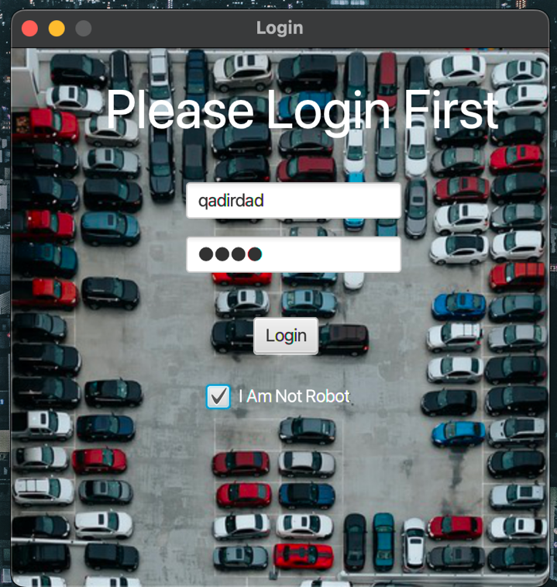

**LOGIN PAGE ERROR :**

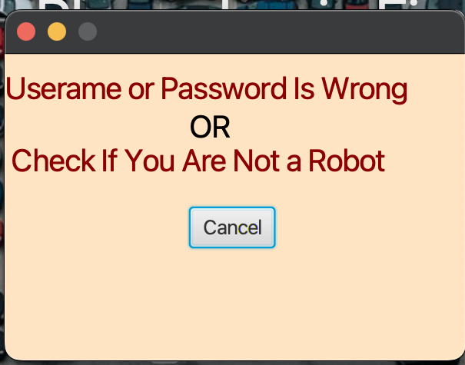

**MAIN PAGE :**

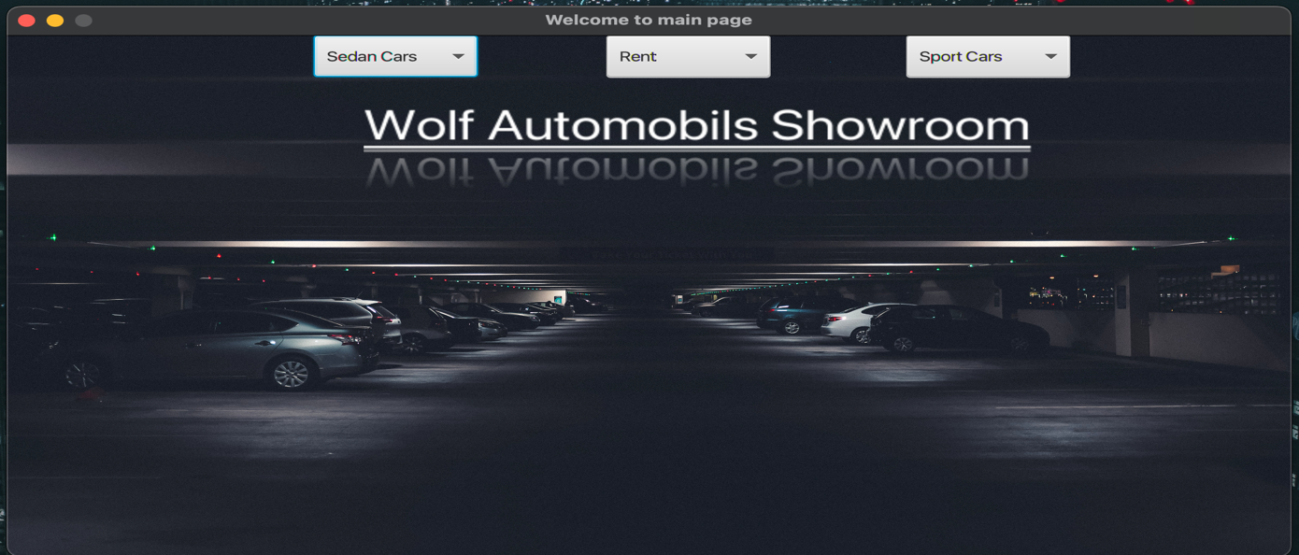

**SEDAN CARS NEW:**

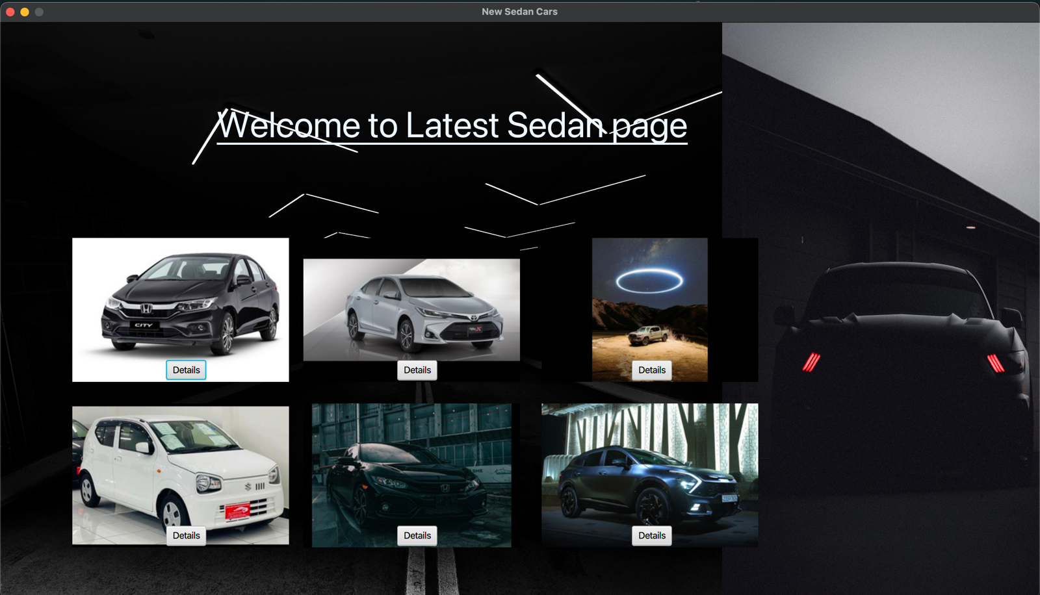

**SEDAN car OLD:**

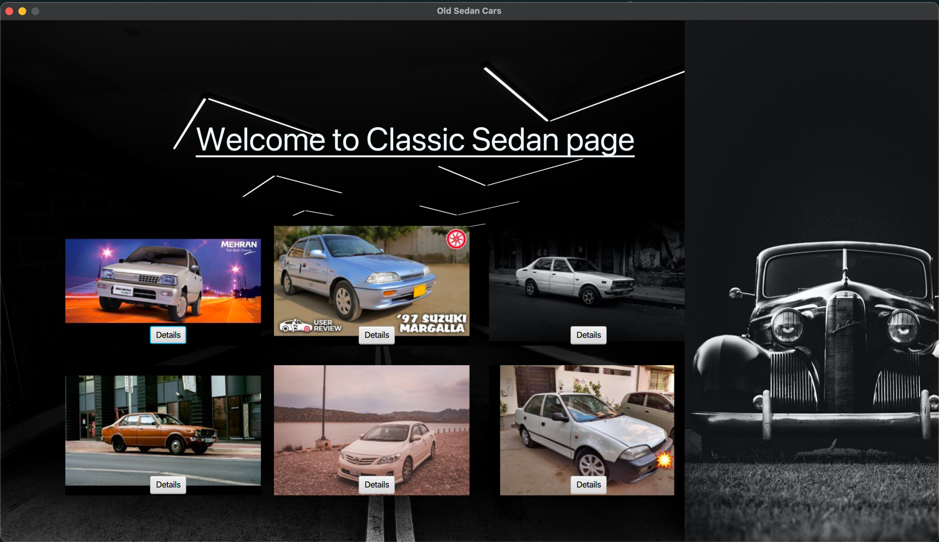

**RENT A CAR:**

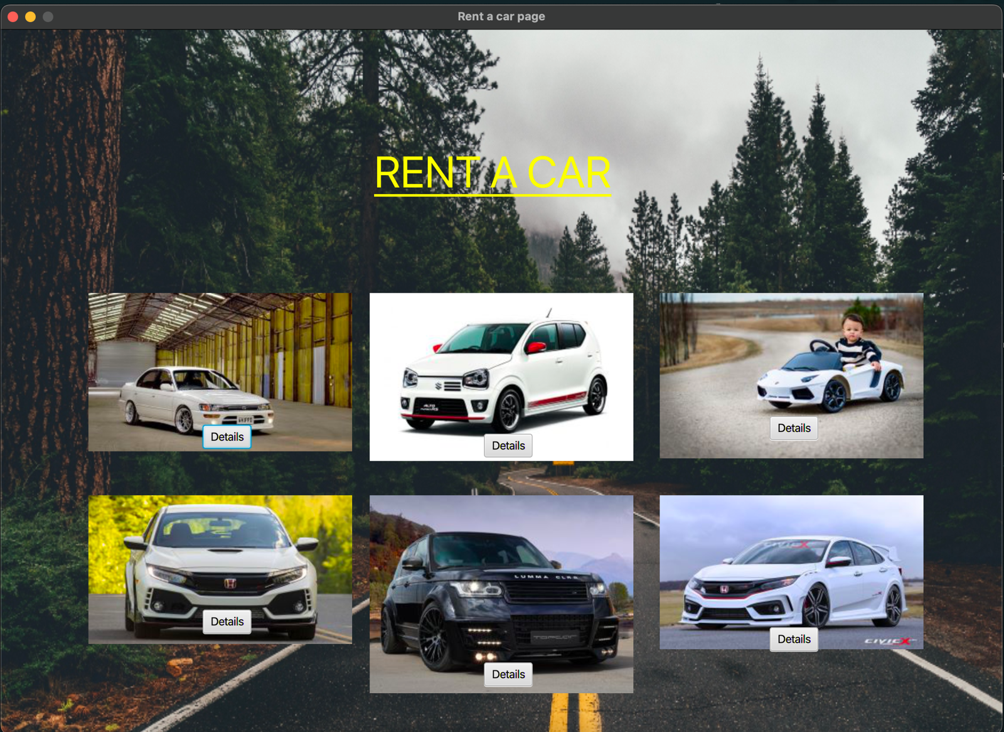

**New Sports car:**

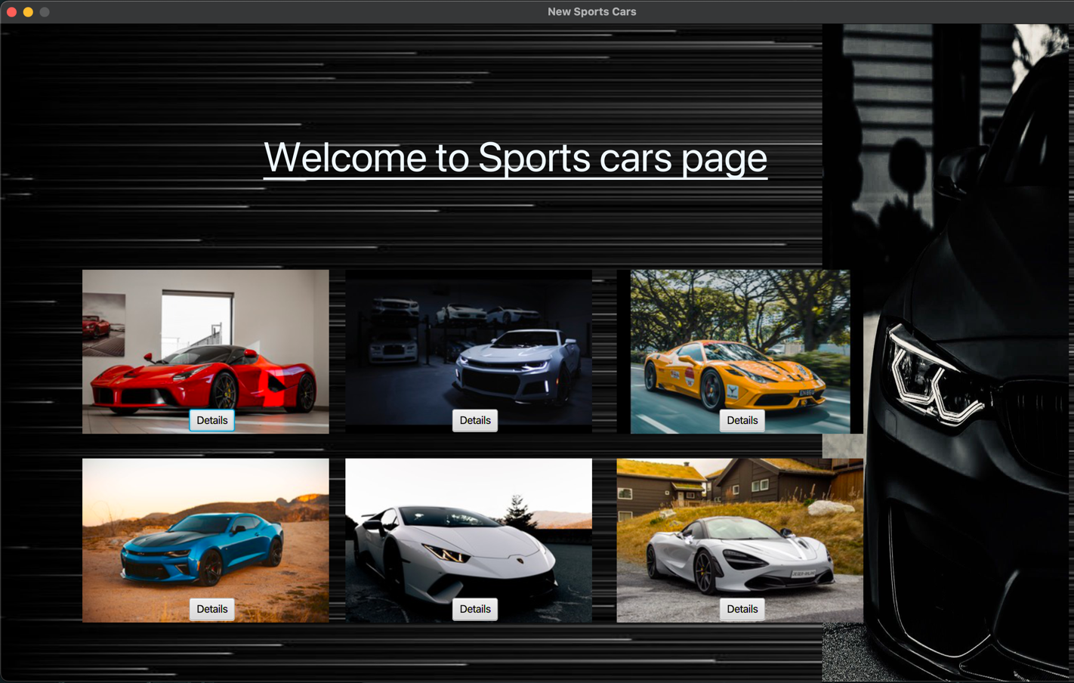

**OLD Sports Car:**

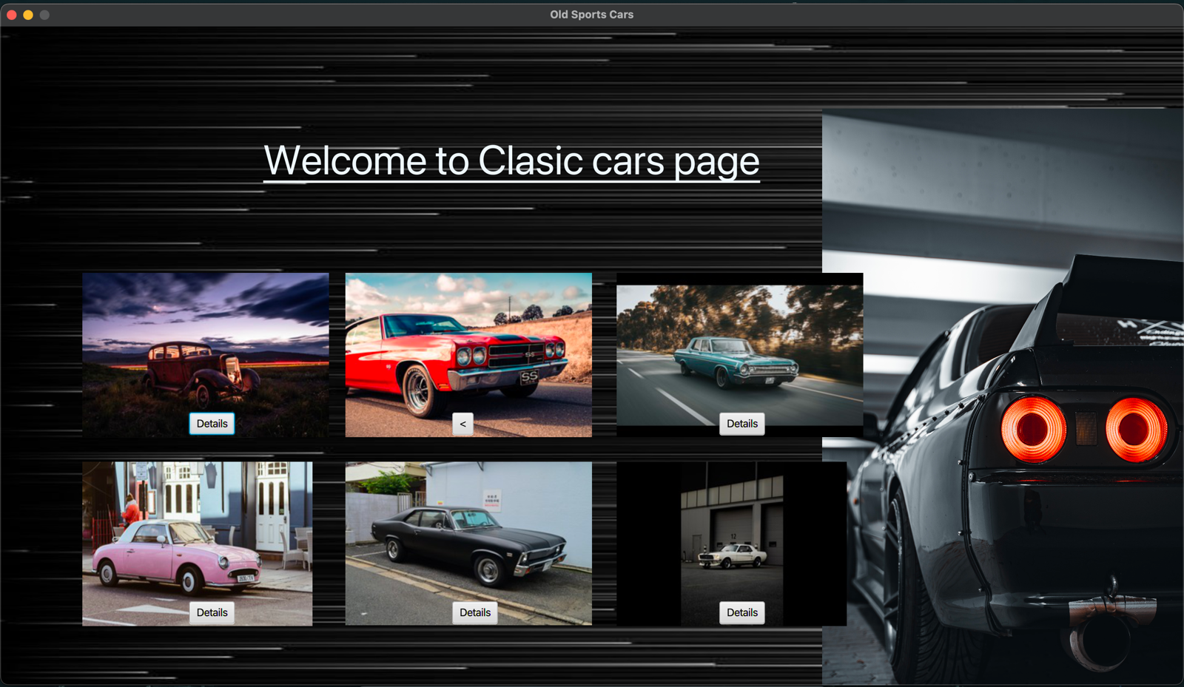

**BUY:**

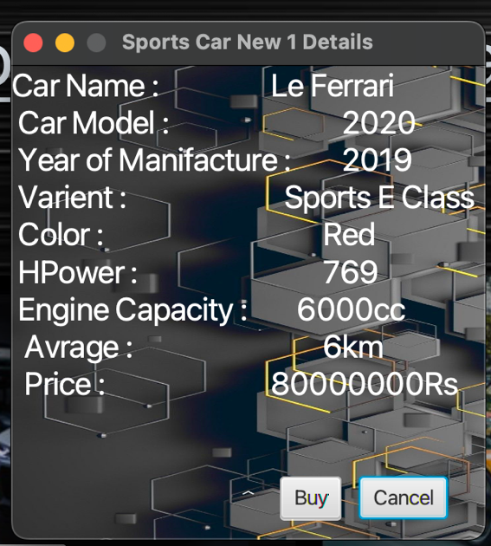

**PAYMENT METHOD:**

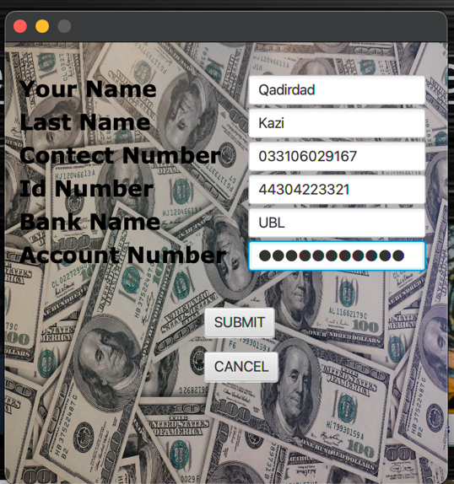

**SAVING INFORMATION:**

